**28.4.1.1**

I would use the SPI4 channel. It uses SDI4 (F4), SSO4(F5) and SCK4(B14) on the NU32 board.

**28.4.1.2**

I would use AN0 as the ADC input. It is the B0 pin on NU32.

**28.4.1.3**

I would use RD1(D1) as the digital output and OC1(D0) with Timer3 as the Output Compare for the PWM.

**28.4.1.4**

I would use the Timer2 for the 200Hz position control and use priority = 6.

I would use Timer1 with 1:1 prescaler for the 5kHz current control ISR and use priority = 5.

**28.4.1.5**

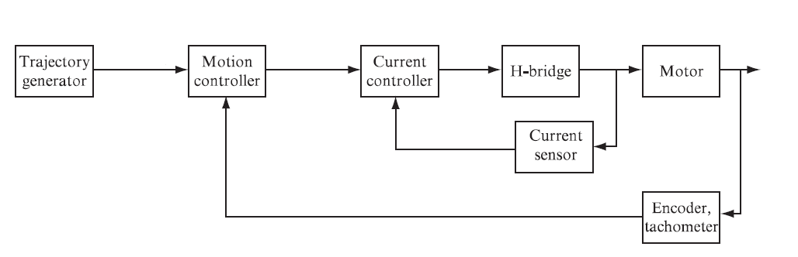

DRV8835

AN0

OC1 and RD1

B0

D1 and D0

dsPIC33F

SPI4

F4, F5 and B14

**28.4.1.6**

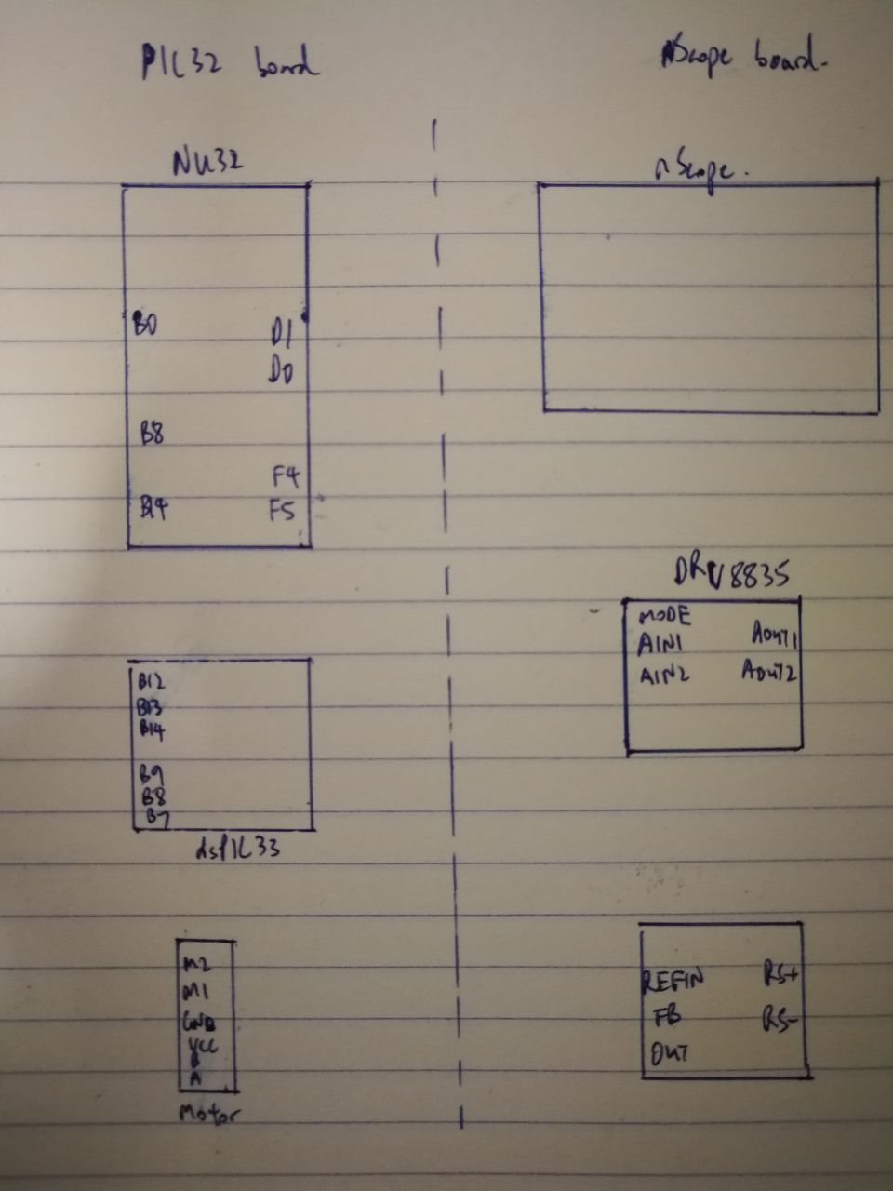

**28.4.7.2**

Measured: V = 6V and Rmotor = 12Ω

Then Imax = 0.5A

**28.4.7.3**

Vmax = 0.015Ω x 0.5A = 0.0075V

**28.4.7.4**

G = 1.65V / 0.0075V = 220 → R2 / R1 = 219

Select R1 = 10 kΩ, R2 = 2000 kΩ (R2 / R1 = 200)

**28.4.7.5**

R = 1 kΩ, C = 1 μF → f = 160 Hz (close to 200 Hz)

**28.4.7.6**

For V = 6V:

|  |  |  |  |  |
| --- | --- | --- | --- | --- |
| R0 (Ω) | Expected I (mA) | Measured I (mA) | Sensor (V) | ADC (counts) |
| 10 (to RS+) | 600 | 522 | 2.42 | 761 |
| 20 (to RS+) | 300 | 288 | 2.06 | 639 |
| 40 (to RS+) | 150 | 150 | 1.86 | 574 |
| Open Circuit | 0 | 0 | 1.65 | 502 |
| 40 (to RS-) | -150 | -150 | 1.39 | 427 |
| 20 (to RS-) | -300 | -280 | 1.20 | 360 |
| 10 (to RS-) | -600 | -508 | 0.81 | 239 |

**28.4.9.8**

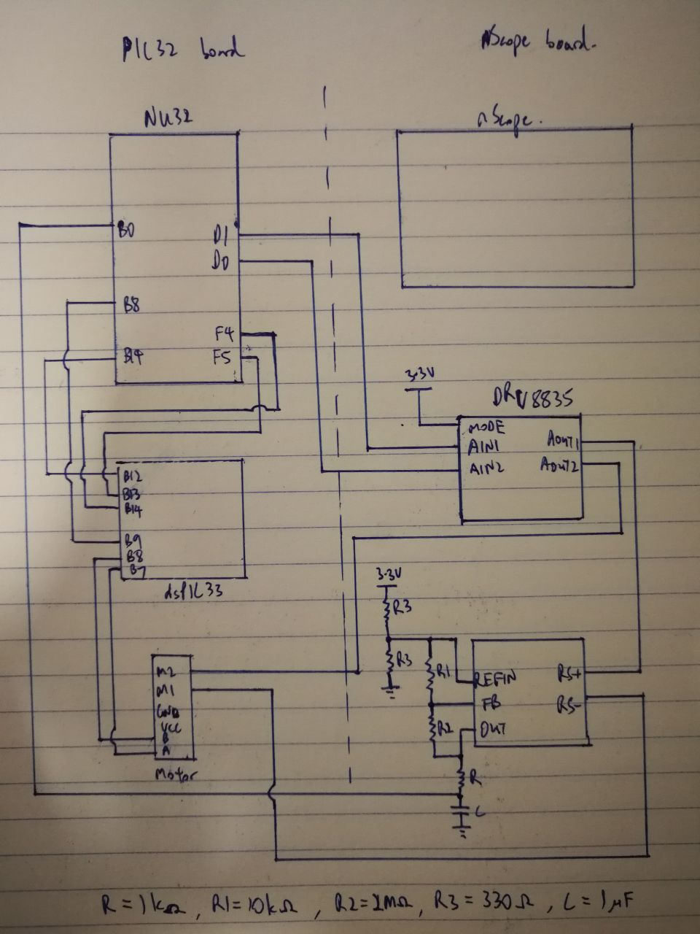

**28.4.10.5**

Kp = 830, Ki = 230

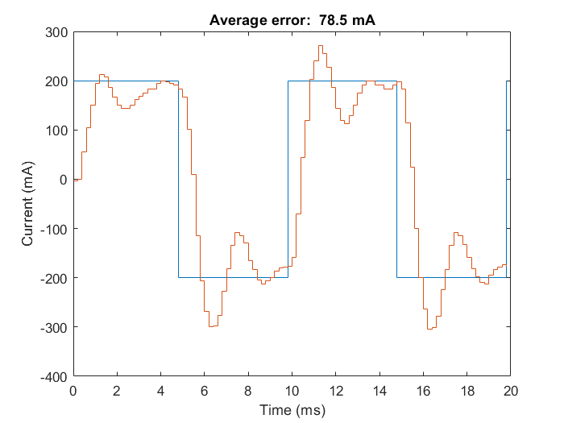

**28.4.12.5**

Kp = 500, Ki = 10, Kd = 150:

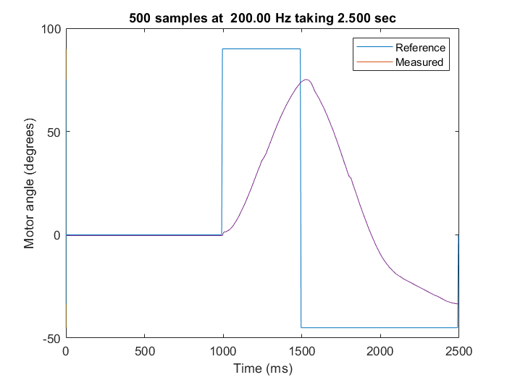

**STEP INPUT**

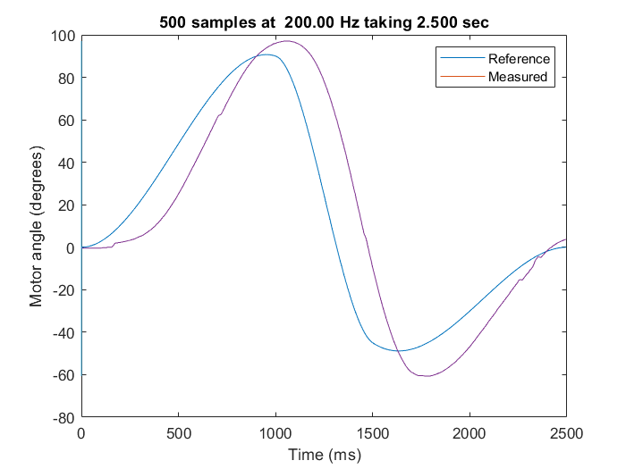

**CUBIC INPUT**